Eulalie Prayer

EULALIE — The quality of your visit to the poor and the sick draws me to prayer. You teach me so about welcoming others and being other‐centered. You hurried quickly to where the need was. You thought of others. You gave them joy, hope and promise, or rather, you allowed the Lord to do all that through you. You trusted in your God.

EULALIE — Is that why you could give and share and were destined to found a Congregation of women religious dedicated to the Holy Names of Jesus and Mary? You touched the heart of one young woman who had been a source of scandal to the town because of her careless manner of living. She was so impressed by the sight of you, Eulalie, kneeling in silent prayer, that she felt the grace of conversion at that moment. You touched this woman's spirit and she felt the goodness of God in her life.

EULALIE — You understood so well God's great love for you. You trusted God so totally. Your welcoming presence met the needs of your people and they cried out in recognition of the fullness of God within you.

EULALIE — Dear woman of God, pray for us, that we can be spiritual people of quality, of promise, of welcoming presence. Help us to be full of hospitality, welcoming the Christ in all and allowing the Christ within us to be met and visited.

AMEN
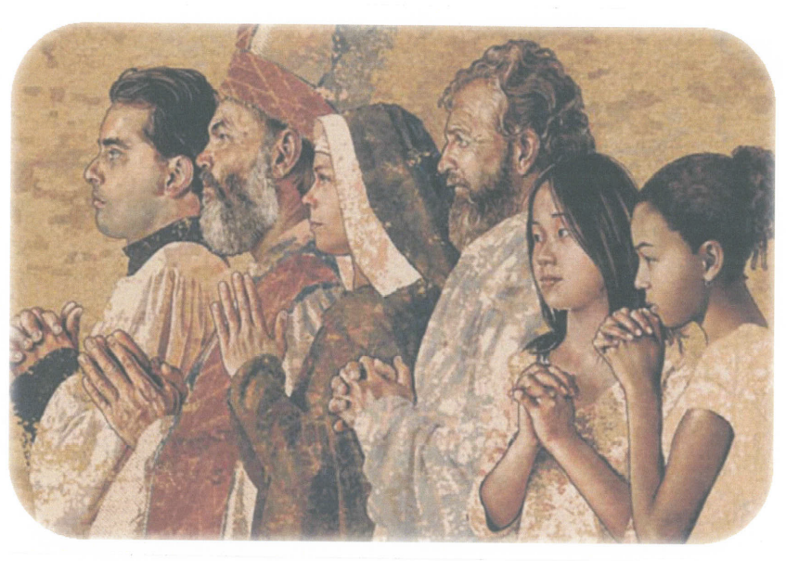
Jeannine Larocque, SNJM Associate
Tapestry: Cathedral of Our Lady of the Angels
Los Angeles, California
Artist: John Nava

