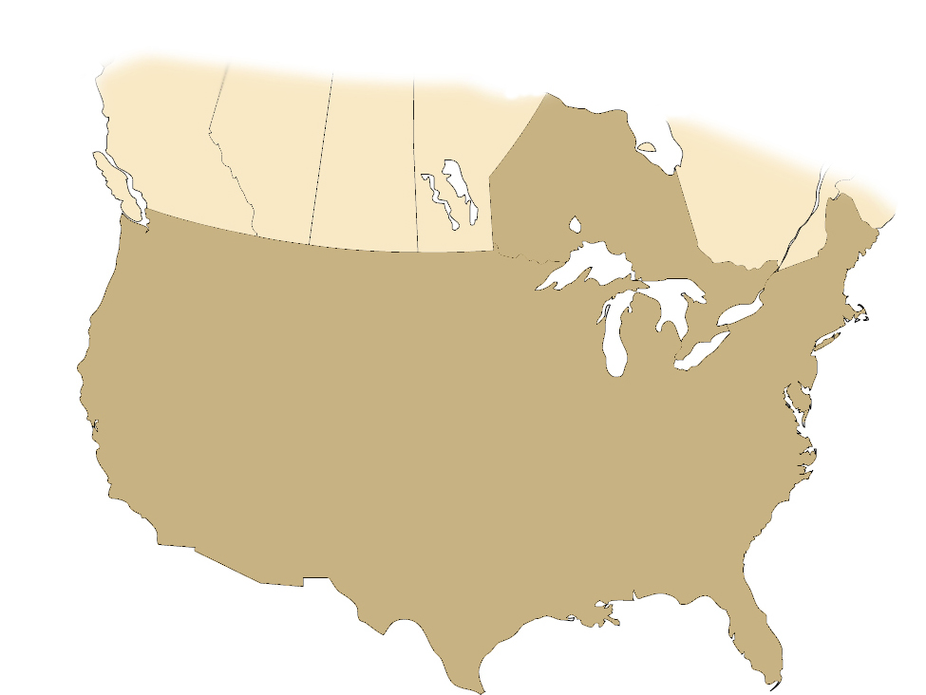

**Associate Regions and Area Counts**

Sisters of the Holy Names

U.S.-Ontario Province

Windsor, ON (22)

Albany, NY (27)

Tampa, FL (11)

Mid-Atlantic (6)

Northern CA (50)

Yakima, WA (41)

Spokane, WA (30)

Oregon (85)

Southern CA (43)

Everett, WA (10)

Seattle, WA (26)

Puyallup/Tacoma, WA (9)